Welcome to the Dovedale Restaurant
at The Paramount Palace Hotel
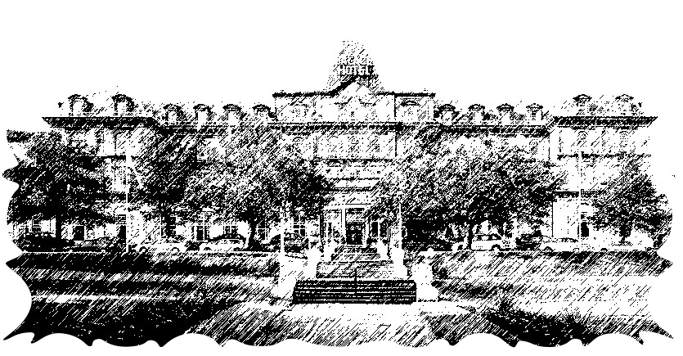

The Palace Hotel is one of the few remaining hotels built in the Grand Victorian style still operating outside the major cities. Built under the patronage of the Duke of Devonshire the Palace Hotel opened its doors to guests on June 6th 1868. The main staircase is the longest wrought iron staircase in England. During the First World War it was taken over by the Canadian Forces as a billet and hospital.

Buxton is a beautiful 18th century market town at the heart of the Peak District, surrounded by stunning countryside and renowned for its thermal Spa water which, incidentally, persuaded the Romans to stay a while (warm water!). The old thermal baths were extremely popular at the end of the last century for therapeutic healing and well-being. The Pavillion Gardens with its Winter Gardens are home to antique crafts and specialist fairs. Poole’s Cavern and Country Park, set in woodland one mile from the town centre offers the natural wonders of a limestone cavern.

Dear Guest

Welcome to the Dovedale Restaurant where you will experience excellent cuisine, fine wine and a relaxing ambience.

We have a Table d’hote Menu as well as A La Carte dishes which have been freshly prepared by our Executive Chef, Eian Elwood and his brigade.

If you prefer a dish that is not featured on our menu or you would prefer one of our dishes in a more simple manner then please ask a member of our team and we will do our utmost to accommodate you.

Eian and myself do hope you enjoy your dining experience with us this evening and again, if we can help in anyway please ask!

Kind regards

Sarah Niven Eian Elwood
Restaurant Manager Executive Chef

Starters

 | Price | Supplement
Chef’s Home-made Soup of the Day | £4.75
Pressed Ham Hock & Parsley Terrine, with Fig  Chutney and Balsamic Syrup | £4.75
Warm Leek & Cheddar Cheese Tartlet with  Dressed Endive & Apple Vinaigrette | £4.75
Pineapple and Watermelon drizzled with  Lemongrass and Ginger syrup | £4.75
Sautéed Field Mushrooms in a Garlic, Tarragon and  White Wine Cream on toasted Ciabatta | £6.95 | £2.50
Classic Prawn Cocktail | £7.50 | £3.50
Traditional Platter of Smoked Salmon  served with Lemon, Capers, Onion and Egg | £8.50 | £4.95
For guests staying on a dinner inclusive rate, supplement dishes or side orders  will be added to your bill at the supplement price indicated on the menu |  | 1

Main Courses

 | Price | Supplement
Baked Cod Fillet on Creamed Basil  Mash with Wilted Greens | £14.00
Daube of Beef on Horseradish Mash with Root Vegetables | £14.00
Chicken Fillet Pan-fried with Honey & Lime, on  Coriander Noodles with Vegetable Crisps | £14.00
Honey & Rosemary Roasted Root Vegetables, with  Toasted Pine-nuts and Crispy Noodles | £14.00
Pan-fried Duck Breast, with Creamed Savoy Cabbage,  Parmentier Potatoes, a Sugar-glazed Plum and Red Wine Jus | £17.50 | £6.95
Pan-fried Salmon Fillet, Saffron Risotto,  Asparagus and Truffle Oil | £18.00 | £7.50
Char-grilled Sirloin Steak au Poivre,  Brick Chips, Onion Rings and Tomato | £18.95 | £8.95

Side Dishes

Hand-cut Chips  Minted New Potatoes  Tomato and Red Onion Salad  Panaché of Seasonal Vegetables  Roquette and Parmesan Salad with Balsamic  For guests staying on a dinner inclusive rate, supplement dishes or side orders  will be added to your bill at the supplement price indicated on the menu |  | £2.95 each  1

Sweets

 | Price | Supplement
Bakewell Pudding and Vanilla Ice-cream | £4.25
Toffee Ripple Cheesecake with Cherry Compote | £4.25
Bitter Chocolate Torte served with Bailey’s Crème Anglaise | £4.25
Selection of British Cheeses served with  Celery, Grapes and Biscuits | £5.00 | £1.75
Assiette of Desserts; Tiramisu, Rich Nut Chocolato  and White Chocolate Parfait | £6.50 | £ 2.75
Dessert Wine & Port:-

Brown Brothers Late Harvested Orange Flora & Muscat 2002  Intensely fragrant and fruity | 125 ml glass | £5.00
Cockburns Ruby Port  A perfect accompaniment to our Cheese and Biscuits | 50ml Glass | £2.20
For guests staying on a dinner inclusive rate, supplement dishes or side orders  will be added to your bill at the supplement price indicated on the menu |  | 1

Hot Drinks Menu

Twinings Tea | English Breakfast, Assam, Earl Grey, Darjeeling  and a Selection of Fruit and Herbal Teas available | £2.40
Freshly Ground Coffee | Small Cafetiére  Large Cafetiére | £2.40  £6.00
Espresso | Hot water is pumped through finely ground coffee to produce a short strong dark coffee topped with an attractive crema, the sign of a true espresso | £2.40
Americano | A long black coffee made in the espresso tradition but with twice as much water | £2.40
Cappuccino | A milky coffee made from equal proportions of espresso, steamed milk and a foamed milk topping | £2.90
Macchiato | A shot of espresso with a frothed milk topping | £2.90
Latte | A layered coffee made from espresso with  a whipped and frothed milk topping | £2.90
Hot Chocolate | Made from hot frothy milk and lightly sprinkled with milk chocolate | £2.90
Liqueur Coffees | All our liqueur coffees are made with fresh filter coffee and your choice of spirit, topped with fresh cream
Irish Coffee | Jameson Irish Whisky | £3.95
French Coffee | Martell VS Cognac | £3.95
Calypso Coffee | Tia Maria Liqueur | £3.95
Jamaican Coffee | Lamb’s Navy Rum | £3.95

